Step :1 :-- Load the csv data kddcup99.csv and results are below:

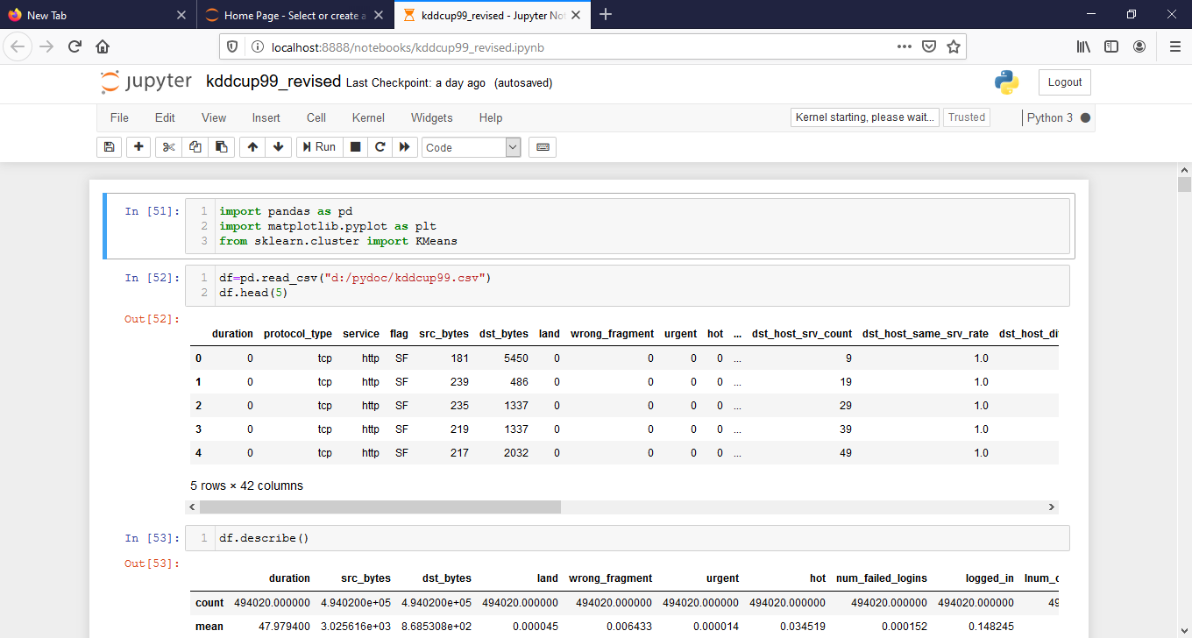

Step 2:-- scattering results of two columns of this selection.

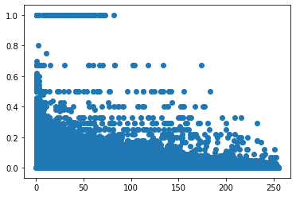

Step 3: -- K means clustering results.

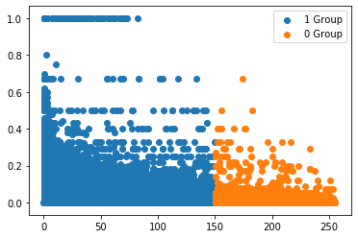

Step 4: -- kmeans clustering results after prediction.

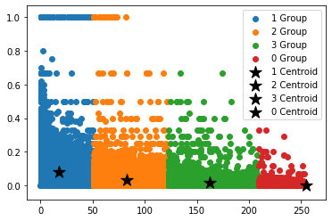

Step 5: -- k means score by linear regression(hybrid k means( k means + linear regression))

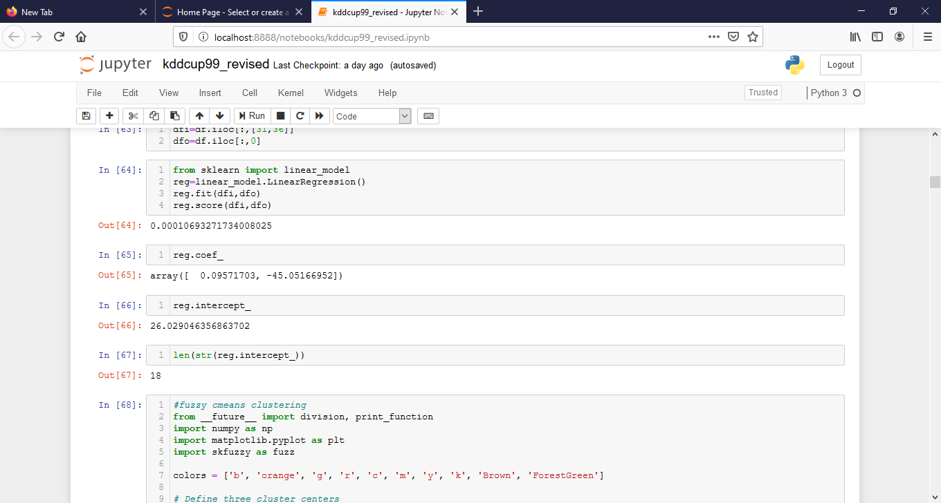

Step 6: -- fuzzy c means clustering of two columns.

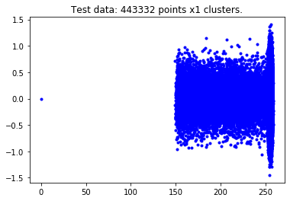

Step 7: -- fuzzy c means point centers representation.

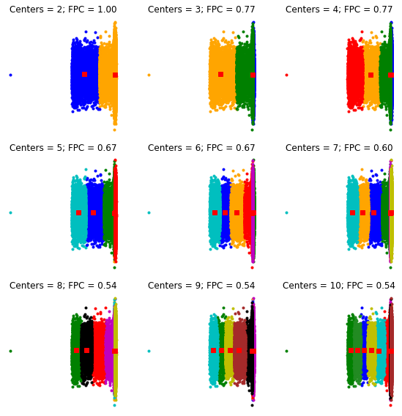

Step8: -- fuzzy partition coefficient.

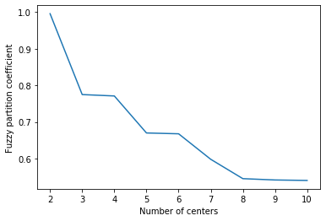

Step 9: -- regenerate fuzzy model with 3 cluster centers

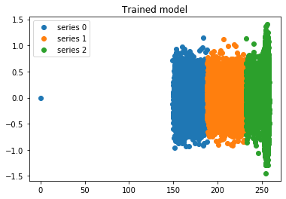

Step 10: -- Random points classification according to known centers.

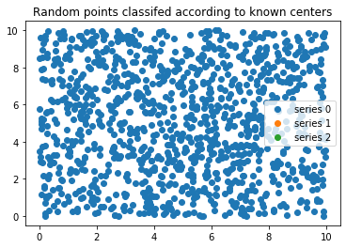

Step 4: -- fuzzy c means prediction score.

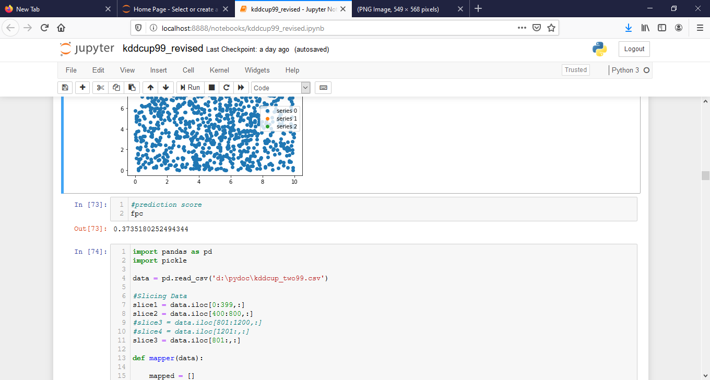

Step 9: -- average score up to eight columns after reducer technique.

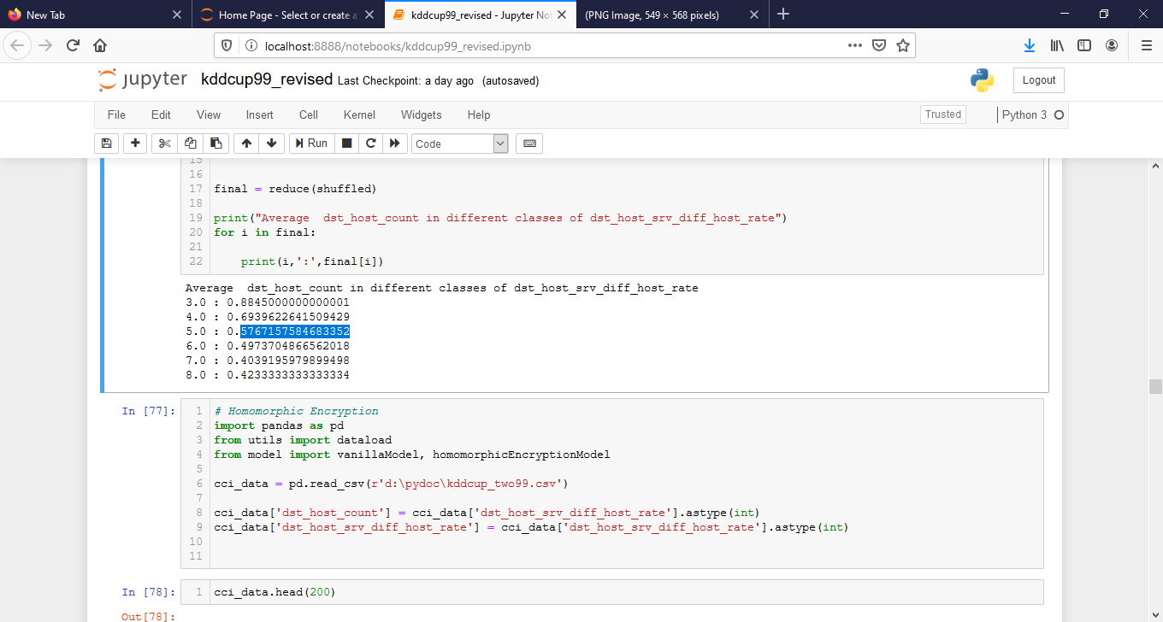

Step 10: -- Homomorphic encryption model output representation.

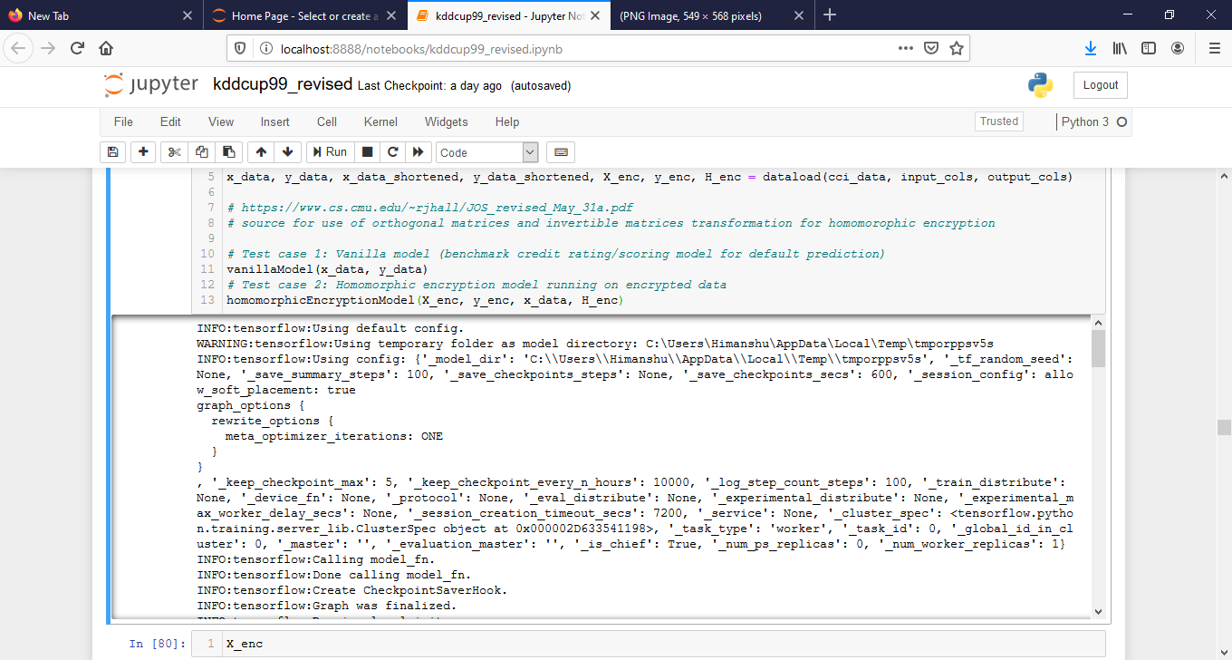

Step 11: -- particle swarm optimization algorithm with optimization after homomorphic encryption model.

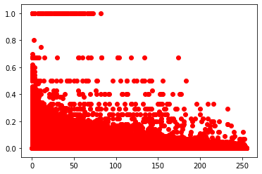

Step 12 : -- pso fitness score representation.

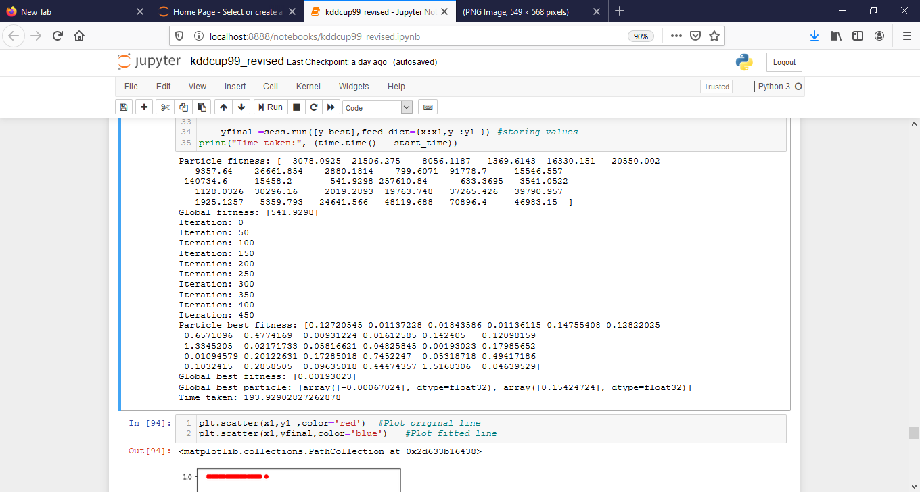

Step13: -- clustering representation of fitness of pso.

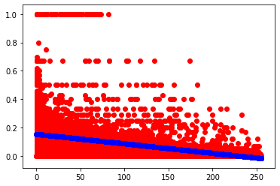

Step 14: -- encrypted data in csv file representation by implementation of cipher text encryption.

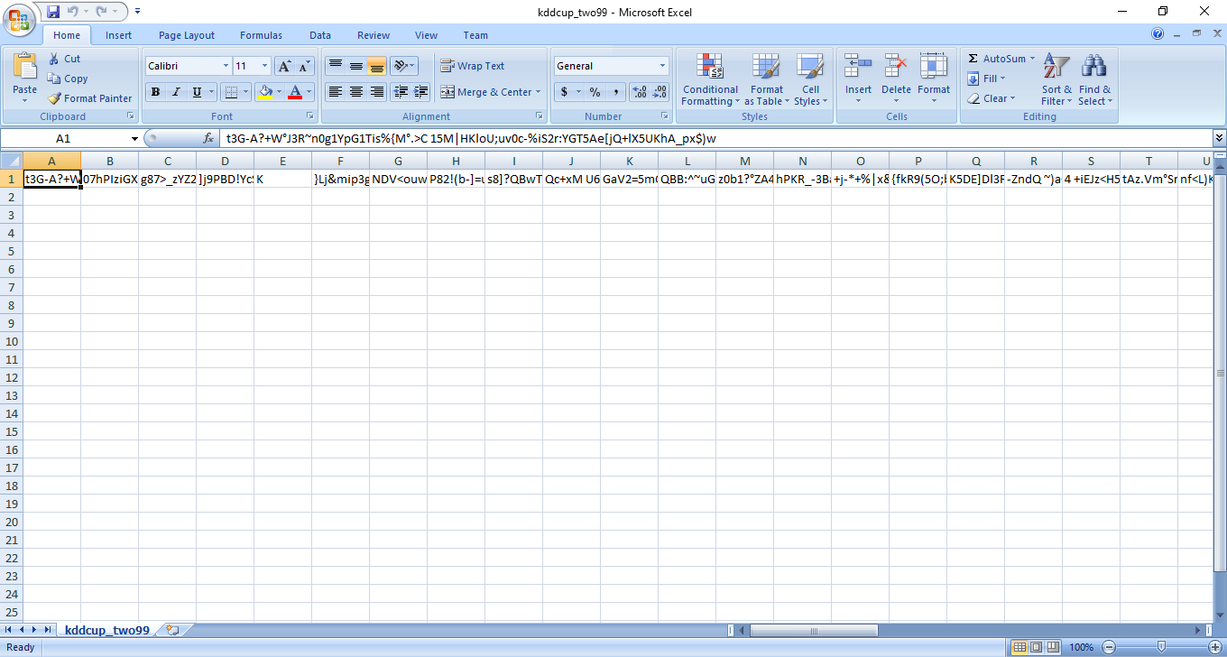

Step 15: -- simple data in csv file representation without implementation of cipher text encryption.

